**Project 1**

**<Mexico Dice Game>**

**CSC-5 42483**

**Name: Nuno, Sergio**

**Date: 4/23/2018**

**Introduction**

Title: Mexico

This is a dice game that is required to have more than one player and a pair of dice.

**Summary**

Project size: about 360 lines

The number of variables: about 40

In my project I have manage to added what we have learned of the chapters that we have gone over, and there is a lot I can add on from this upcoming chapter to better this project.

**Pseudo Code**

*Initialize*

*If input 2*

*Output number of lives*

*Output the loser*

*end*

*If input 3*

*Output number of lives*

*Output the loser*

*end*

*If input 4*

*Output number of lives*

*Output the loser*

*end*

*If input 5*

*Output number of lives*

*Output the loser*

*end*

*If input 6*

*Output number of lives*

*Output the loser*

*end*

*If input 1,7-inf*

*Output Exiting Game*

*end*

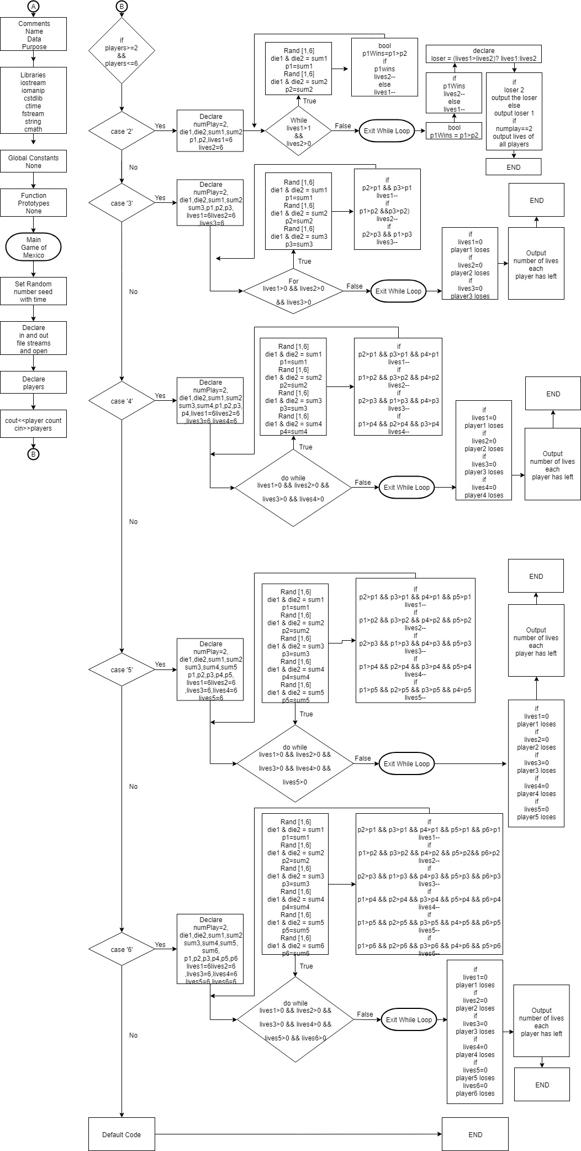**Flowchart**